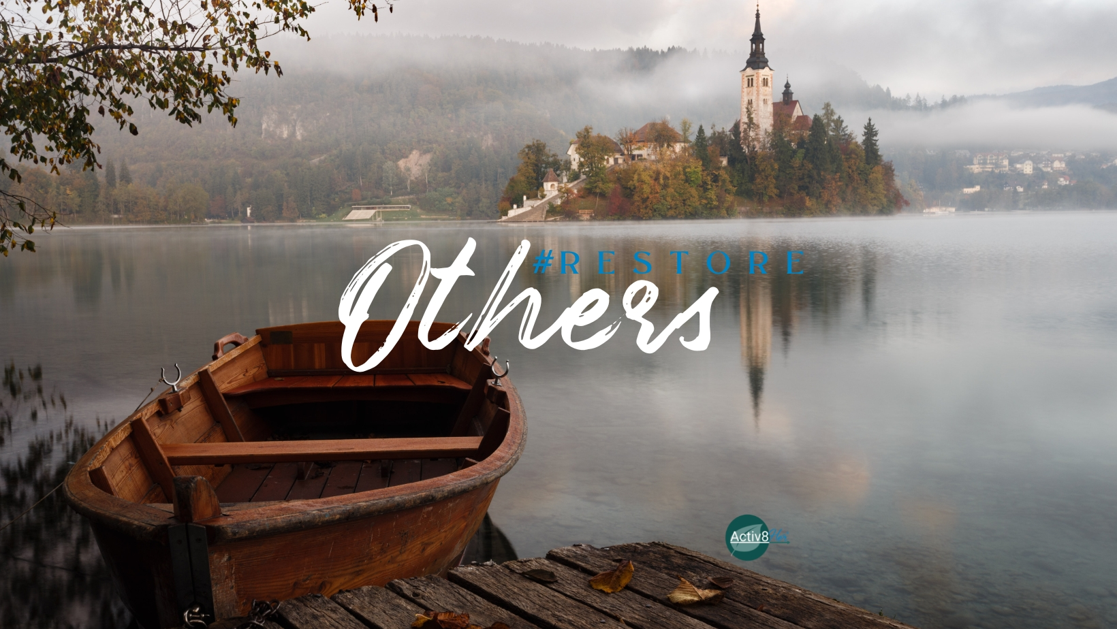
#RestoreOthers Study Guide
Verse: “Arise, go to Nineveh, that great city, and cry out against it; for their wickedness has come up before Me” (Jonah 1:2, NKJV).
Historical facts on the life of Jonah: 790-760 BC
- Reign of Jeroboam ii - King of Israel (evil). 18th century B.C.
- Israel was in the midst of a new period of greatness: a time of great prosperity and strength for northern and southern kingdoms.
- In 2 Kings 14:25 we see how God used the prophet, Jonah.
- Nineveh:
  - Built by Nimrod - a great city
  - The city of Nineveh was the magnificent capital of the Assyrian Empire.
  - Sennacherib, King of Assyria built his palace here.
  - Read Zephaniah’s prophecy in chapter 2:13-15 AMP.
Jonah’s trip to Nineveh was 550 miles, but he went to Tarshish, which was 2500 miles in the opposite direction. “I can never escape from your Spirit! I can never get away from your presence!” (Psalm 139:7, NLT)
- When have you avoided going where you knew God was calling you?
- What was your motivation in doing so?
Jonah quoted: Exodus 34:6,“Jehovah, Jehovah God, merciful and gracious, slow to anger, and abundant in kindness and truth” BUT Jonah said, “I have known that Thou [art] a God, gracious and merciful, slow to anger, and abundant in kindness, and repenting of evil.” (Jonah 4: 1-2, NKJV, emphasis ours).
Why do you suppose Jonah didn’t want to acknowledge God’s character trait of Truth in this moment?

If Jonah’s view of God was too restrictive, is it possible that ours is, too?
Is it possible that we fail to recognize certain aspects of God’s character that make us uncomfortable? Do we see potential in others the way God does?
“Jonah is angry because his view of God right now is ‘I know who you are, but do you know who you are not? You don’t care about the truth because if you did, you would not restore our enemies.’” —Mary Solomon
Can you relate to Jonah’s frustration with God? How?
Why would God use enemies to restore one another?
Where are you seeking restoration in your life right now?
Activ8tion Plan:
God’s view of you is not diminished by His love and forgiveness of others. Can you accept this?
Can you live within the Kingdom of God and take on a kingdom identity and do what God is asking even when we may not like it or understand it?
Do you know God for who He is or have you created Him in your image, rather than the other way around? This month, do a character study on God. Be ready to share your discoveries at the second meeting. What did you learn about Him that you didn’t know? Did you have a mischaracterization He corrected?

