#BU

Declaration Cards:
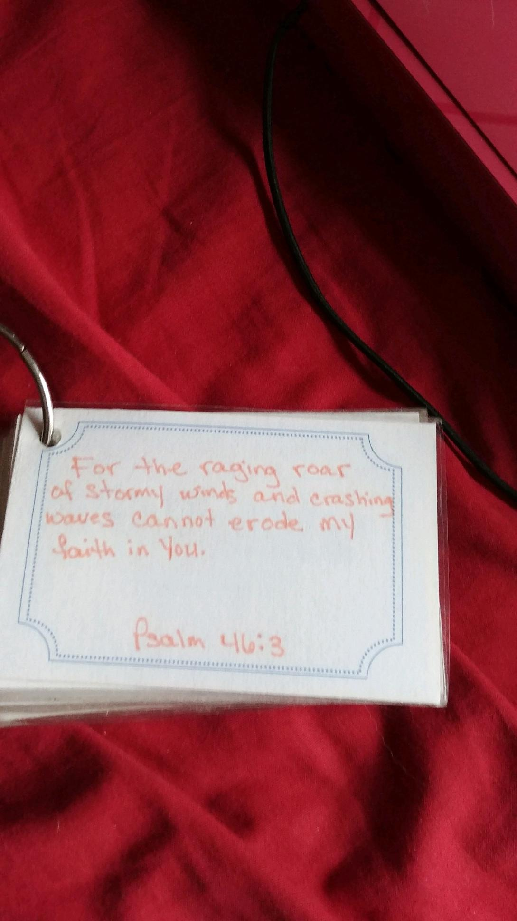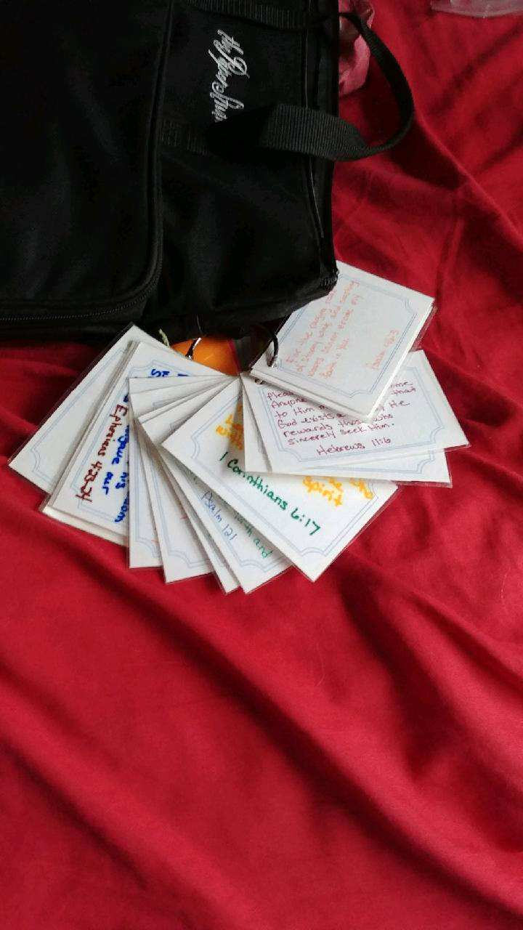

Materials needed: Metal ring, cards (template), markers, hole punch, laminate sheets and identity verses. Enjoy a time of fellowship around a table as the ladies write out the verses and make a ring of declaration cards to keep with them.

Verses and cards attached.

Your Identity in Christ

“But the person who is joined to the Lord is one spirit with him” (1 Corinthians 6:17, NLT).

“We know that our old sinful selves were crucified with Christ so that sin might lose its power in our lives. We are no longer slaves to sin” (Romans 6:6, NLT).

“By his divine power, God has given us everything we need for living a godly life. We have received all of this by coming to know him, the one who called us to himself by means of his marvelous glory and excellence” (2 Peter 1:3, NLT).

“Instead, let the Spirit renew your thoughts and attitudes. Put on your new nature, created to be like God—truly righteous and holy” (Ephesians 4:23-24, NLT).

“He is so rich in kindness and grace that he purchased our freedom with the blood of his Son and forgave our sins” (Ephesians 1:7, NLT).

“He has showered his kindness on us, along with all wisdom and understanding” (Ephesians 1:8, NLT).

“This means that anyone who belongs to Christ has become a new person. The old life is gone; a new life has begun” (2 Corinthians 5:17, NLT)!

“But thank God! He has made us his captives and continues to lead us along in Christ’s triumphal procession. Now he uses us to spread the knowledge of Christ everywhere, like a sweet perfume” (2 Corinthians 2:14, NLT).

“Those who are spiritual can evaluate all things, but they themselves cannot be evaluated by others. For, ‘who can know the Lord’s thoughts? Who knows enough to teach him?’ But we understand these things, for we have the mind of Christ” (1 Corinthians 2:15-16, NLT).

“So now there is no condemnation for those who belong to Christ Jesus. And because you belong to him, the power of the life-giving Spirit has freed you from the power of sin that leads to death” (Romans 8:1-2, NLT).

“So you also should consider yourselves to be dead to the power of sin and alive to God through Christ Jesus” (Romans 6:11, NLT).

“Therefore, since we have been made right in God’s sight by faith, we have peace with God because of what Jesus Christ our Lord has done for us” (Romans 5:1, NLT).

“So just as sin ruled over all people and brought them to death, now God’s wonderful grace rules instead, giving us right standing with God and resulting in eternal life through Jesus Christ our Lord” (Romans 5:21, NLT).

Your Identity in Christ

“He personally carried our sins in his body on the cross so that we can be dead to sin and live for what is right. By his wounds you are healed” (1 Peter 2:24, NLT).

“And because of his glory and excellence, he has given us great and precious promises. These are the promises that enable you to share his divine nature and escape the world’s corruption caused by human desires” (2 Peter 1:4, NLT).

“In his kindness God called you to share in his eternal glory by means of Christ Jesus. So after you have suffered a little while, he will restore, support, and strengthen you, and he will place you on a firm foundation” (1 Peter 5:10, NLT).

“Now may the God of peace—who brought up from the dead our Lord Jesus,
the great Shepherd of the sheep, and ratified an eternal covenant with his blood—may he equip you with all you need for doing his will. May he produce in you,
through the power of Jesus Christ, every good thing that is pleasing to him.
All glory to him forever and ever! Amen” (Hebrews 13:20-21, NLT).

“Yet now he has reconciled you to himself through the death of Christ in his physical body. As a result, he has brought you into his own presence, and you are holy and blameless as you stand before him without a single fault” (Colossians 1:22, NLT).

“For he has rescued us from the kingdom of darkness and transferred us into the Kingdom of his dear Son, who purchased our freedom and forgave our sins” (Colossians 1:13-14, NLT).

“But there will be glory and honor and peace from God for all who do good—for the Jew first and also for the Gentile” (Romans 2:10, NLT).

“Don’t worry about anything; instead, pray about everything. Tell God what you need, and thank him for all he has done. Then you will experience God’s peace, which exceeds anything we can understand. His peace will guard your hearts and minds as you live in Christ Jesus” (Philippians 4:6-7, NLT).

“All praise to God, the Father of our Lord Jesus Christ, who has blessed us with every spiritual blessing in the heavenly realms because we are united with Christ” (Ephesians 1:3, NLT).

“Even before he made the world, God loved us and chose us in Christ to be holy and without fault in his eyes” (Ephesians 1:4, NLT).

“God decided in advance to adopt us into his own family by bringing us to himself through Jesus Christ. This is what he wanted to do, and it gave him great pleasure” (Ephesians 1:5, NLT).

“And when you believed in Christ, he identified you as his own by giving you the Holy Spirit, whom he promised long ago” (Ephesians 1:13b, NLT).

Your Identity in Christ

“You are altogether beautiful, my love; there is no flaw in you” (Song of Solomon 4:7, ESV).

“The Spirit of the Lord will come powerfully upon you, and you will prophesy with them; and you will be changed into a different person” (1 Samuel 10:6, NIV).

“I waited patiently for the Lord; and He inclined to me, and heard my cry. He also brought me up out of a horrible pit, out of the miry clay, and set my feet upon a rock, and established my steps. He has put a new song in my mouth—Praise to our God; many will see it and fear, and will trust in the Lord” (Psalm 40:1-3, NKJV).

“If we confess our sins, He is faithful and just to forgive us our sins and to cleanse us from all unrighteousness” (1 John 1:9, NKJV).

“But as many as received Him, to them He gave the right to become children of God, to those who believe in His name” (John 1:12, NKJV).

“For I am the Lord who brought you up from the land of Egypt to be your God; therefore you shall be holy, for I am holy” (Leviticus 11:45, AMP).

“So God created man in His own image, in the image and likeness of God He created him; male and female He created them” (Genesis 1:27, AMP).

“Therefore let it be known to you, brethren, that through this Man is preached to you the forgiveness of sins; and by Him everyone who believes is justified from all things from which you could not be justified by the law of Moses” (Acts 13:38-39, NKJV).

“O Lord, You have searched me and known me” Psalm 139:1, NKJV).
“I will praise You, for I am fearfully and wonderfully made; marvelous are Your works, and that my soul knows very well” (Psalm 139:14, NKJV).

“For I am persuaded that neither death nor life, nor angels nor principalities nor powers, nor things present nor things to come, nor height nor depth, nor any other created thing, shall be able to separate us from the love of God which is in Christ Jesus our Lord” (Romans 8:38-39, NKJV).

“And they overcame him by the blood of the Lamb and by the word of their testimony, and they did not love their lives to the death” (Revelation 12:11, NKJV).

“The Lord will fulfill his purpose for me. Lord, your faithful love endures forever; do not abandon the work of your hands” (Psalm 138:8, CSB).

“and giving joyful thanks to the Father, who has qualified you to share in the inheritance of his holy people in the kingdom of light” (Colossians 1:12, NKJV).

Your Identity in Christ

“For our sake He made Christ [virtually] to be sin Who knew no sin, so that in and through Him we might become [endued with, viewed as being in, and examples of] the righteousness of God [what we ought to be, approved and acceptable and in right relationship with Him, by His goodness]” (2 Corinthians 5:21, AMPC).

“Lord, you alone are my portion and my cup; you make my lot secure” (Psalm 16:5, NIV).

“The Lord has declared today that you are his people, his own special treasure, just as he promised, and that you must obey all his commands” (Deuteronomy 26:18, NLT).

“For whatever is born of God overcomes the world. And this is the victory that has overcome the world—our faith. Who is he who overcomes the world, but he who believes that Jesus is the Son of God” (1 John 5:4-5, NKJV)?

“If any of you lacks wisdom, let him ask of God, who gives to all liberally and without reproach, and it will be given to him” (James 1:5, NKJV).

“Accept one another, then, just as Christ accepted you, in order to bring praise to God” (Romans 15:7, NIV).

“For in Christ all the fullness of the Deity lives in bodily form, and in Christ you have been brought to fullness. He is the head over every power and authority” (Colossians 2:9-10, NIV).

“Before I formed you in the womb I knew you, before you were born I set you apart; I appointed you as a prophet to the nations” (Jeremiah 1:5, NIV).

“But you are a chosen people, a royal priesthood, a holy nation, God’s special possession, that you may declare the praises of him who called you out of darkness into his wonderful light” (1 Peter 2:9, NIV).

“for all of you who were baptized into Christ have clothed yourselves with Christ. There is neither Jew nor Gentile, neither slave nor free, nor is there male and female, for you are all one in Christ Jesus” (Galatians 3:27-28, NIV).

“Since, then, you have been raised with Christ, set your hearts on things above, where Christ is, seated at the right hand of God. Set your minds on things above, not on earthly things. For you died, and your life is now hidden with Christ in God” (Colossians 3:1-3, NIV).

“Do you not know that your bodies are temples of the Holy Spirit, who is in you, whom you have received from God? You are not your own; you were bought at a price. Therefore honor God with your bodies” (1 Corinthians 6:19-20, NIV).

