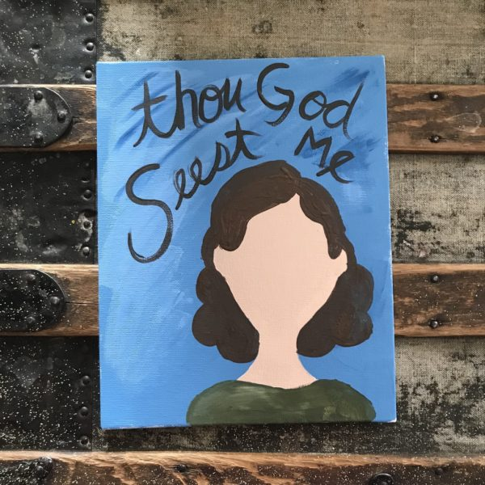
Genesis 16:13 Paint Activity
“He is the God who sees me.”
Use this activity to lay the foundation for a discussion about Sarai and Hagar. See outline provided by Activ8Her under Second Meeting Ideas.
This is laid out as a paint project, but feel free to simplify it by using drawing paper with markers or colored pencils.
It is also permissible to ask those who can to help cover the cost of materials by reimbursing you. ($5-7 ea should more than cover each project)

Materials needed:
- Several paint colors, be sure to include skin tones.
- Paint brushes
- 8x10 canvases
- Tracing paper, optional
- Permanent markers
- Paper plates for paint trays

- Paint entire canvas color of choice. Let dry.
- Have each person choose an avatar that most closely resembles them.
- Draw or trace face and neck. Paint. Let dry.
- Draw or trace shirt and hair. Paint. Let dry.
- Write scripture w/markers or paint. “He is the God who sees me.”

Project created by Montserrat Wadsworth at Cranial Hiccups.

